**Principles of Database Systems, Section B**

# Project_Part_1

Prepared by

**Lingchang Zhou lz2708**

**Tianyi Wang tw2396**

**Dinzge Yu dy2193**

April 4, 2022

## Outline

1. **Description And Assumptions**
2. **Logical Model**
3. **Relational Model**
4. **Table Records**
5. **DDL Code**
6. **DML Code**
7. **Trigger Code**
8. **Queries Results**

## 1. Description & Assumptions

The business case is to build a data management system for WOW which is a car rental company. Based on this, we conduct two entities called CUSTOMER and VEHHICLE. Since a customer may rent several vehicles for one time and a vehicle may be rent for several times by a same customer, we create an Intersect entity called RENT_RECORD. Besides, the customer is divided into individual customer and corporation customer, so we add these two as a sub type of customer. Since WOW mails discount coupons to their customer, we also add entities called INDI_COUPON and CORP_COUPON connected to INDI_CUS and CORP_CUS respectively. Also, vehicle is required to record its class and office location. In order to maintain and update this information in an easier way, we also add these two entities connected to VEHICLE. Finally, we add INVOICE and PAYMENT entity according to the requirements.

Apart from that, we also make several **assumptions:**

1. neighborhood residents who get discount coupons are include in individual customers.
2. we assume that corporation customers already have insurance provided by their corporation.
3. we added coupon ID, office ID, record ID, invoice ID and payment ID for their entities primary key respectively.
4. we assume payment status is divided into pending, success, fail, so we add payment_status in PAYMENT
5. office may not have available vehicles.
6. If the daily_limit attribute in the rent_record table is -1, that means this vehicle has unlimited daily millage.
7. If the status attribute in vehicle is 1 that means this vehicle is ready to be rent, 0 means it it not.

## 2. Logical Model

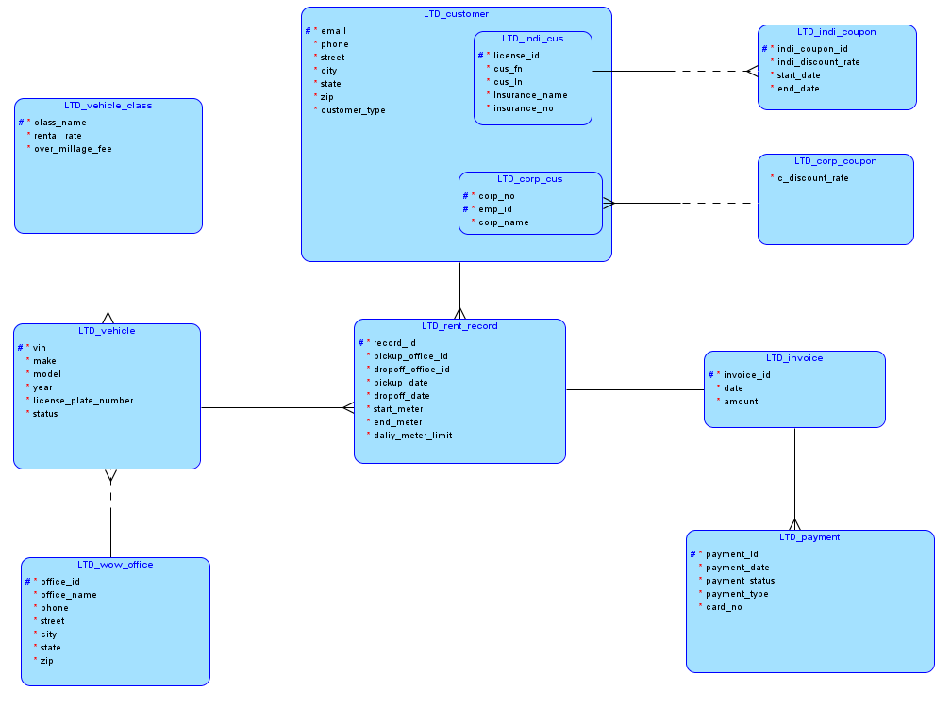

## 3. Relational Model

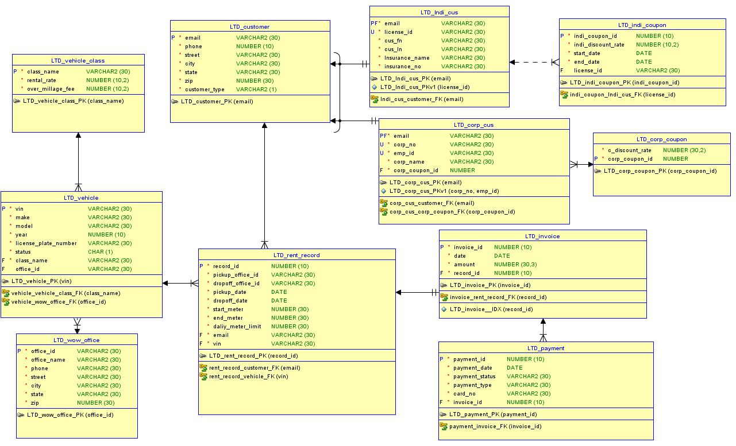

## 4. Table Records

1. LTD_CUSTOMER

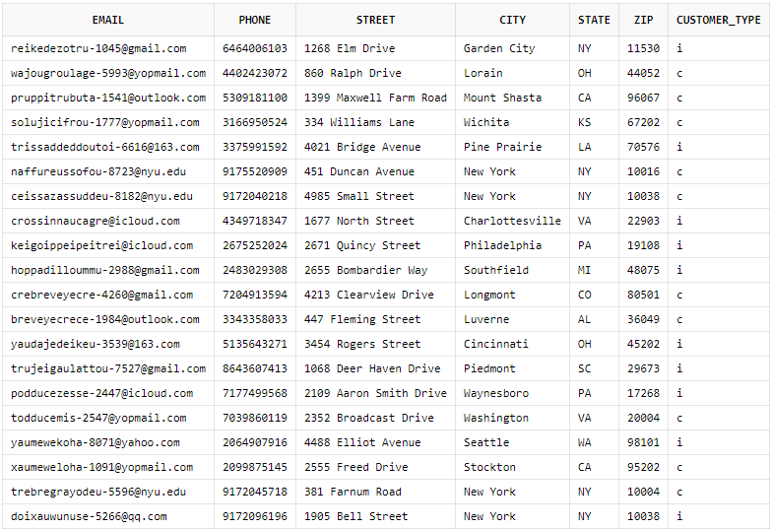

1. LTD_INDI_CUS

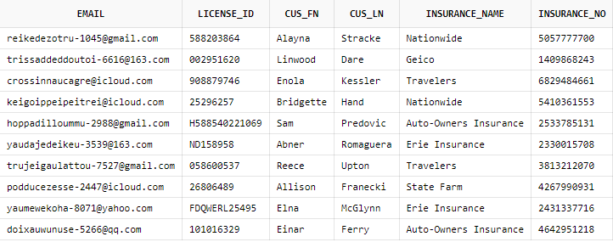

1. LTD_CORP_CUS

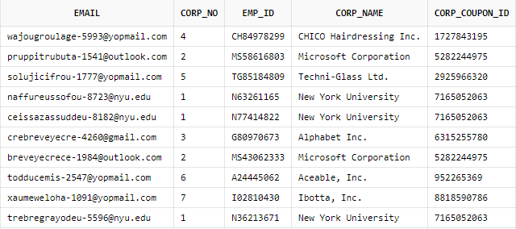

1. LTD_INDI_COUPON

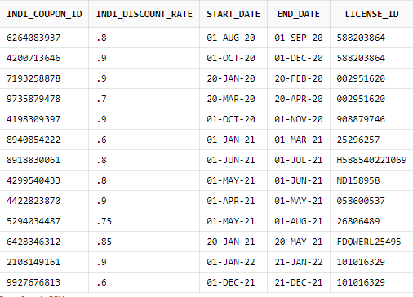

1. LTD_CORP_COUPON

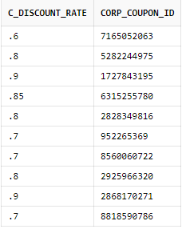

1. LTD_RENT_RECORD

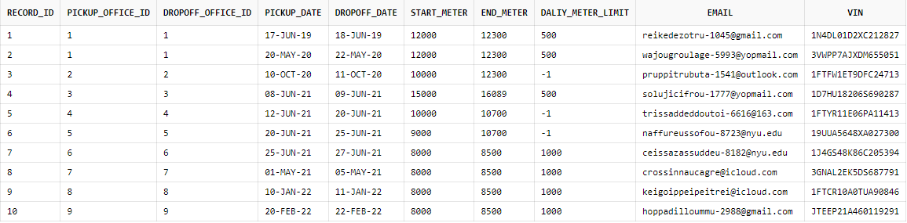

1. LTD_VEHICLE

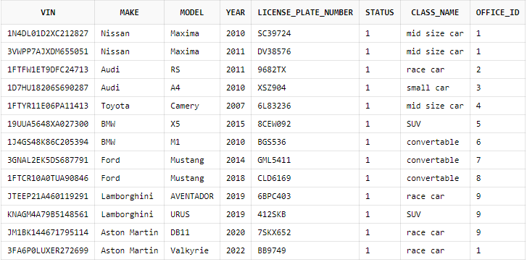

1. LTD_WOW_OFFICE

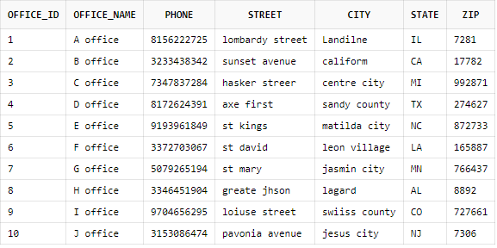

1. LTD_VEHICLE_CLASS

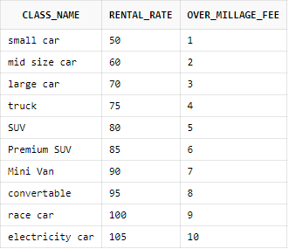

1. LTD_INVOICE

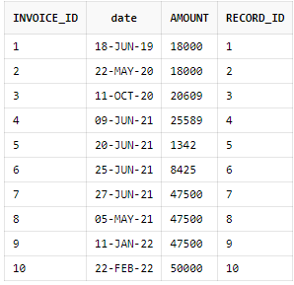

1. LTD_PAYMENT

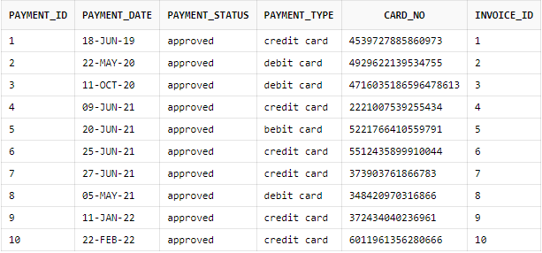

## 5. DDL Code

-- Oracle SQL Developer Data Modeler 21.4.2.059.0838

-- Time: 2022-04-02 12:53:59 EDT

-- Version: Oracle Database 21c

-- Type: Oracle Database 21c

-- predefined type, no DDL - MDSYS.SDO_GEOMETRY

-- predefined type, no DDL - XMLTYPE

CREATE TABLE ltd_corp_coupon (

c_discount_rate NUMBER(30, 2) NOT NULL,

corp_coupon_id NUMBER NOT NULL

);

COMMENT ON COLUMN ltd_corp_coupon.c_discount_rate IS

'the rate of the discount';

ALTER TABLE ltd_corp_coupon ADD CONSTRAINT ltd_corp_coupon_pk PRIMARY KEY ( corp_coupon_id );

CREATE TABLE ltd_corp_cus (

email VARCHAR2(30) NOT NULL,

corp_no VARCHAR2(30) NOT NULL,

emp_id VARCHAR2(30) NOT NULL,

corp_name VARCHAR2(30) NOT NULL,

corp_coupon_id NUMBER NOT NULL

);

COMMENT ON COLUMN ltd_corp_cus.email IS

'email of the customer';

COMMENT ON COLUMN ltd_corp_cus.corp_no IS

'the cop registrartion number';

COMMENT ON COLUMN ltd_corp_cus.emp_id IS

'the employee id of the customer';

COMMENT ON COLUMN ltd_corp_cus.corp_name IS

'the name of the corp';

ALTER TABLE ltd_corp_cus ADD CONSTRAINT ltd_corp_cus_pk PRIMARY KEY ( email );

ALTER TABLE ltd_corp_cus ADD CONSTRAINT ltd_corp_cus_pkv1 UNIQUE ( corp_no,

emp_id );

CREATE TABLE ltd_customer (

email VARCHAR2(30) NOT NULL,

phone NUMBER(10) NOT NULL,

street VARCHAR2(30) NOT NULL,

city VARCHAR2(30) NOT NULL,

state VARCHAR2(30) NOT NULL,

zip NUMBER(30) NOT NULL,

customer_type VARCHAR2(1) NOT NULL

);

ALTER TABLE ltd_customer

ADD CONSTRAINT ch_inh_ltd_customer CHECK ( customer_type IN ( 'c', 'i' ) );

COMMENT ON COLUMN ltd_customer.email IS

'email of the customer';

COMMENT ON COLUMN ltd_customer.phone IS

'phone number of the customer';

COMMENT ON COLUMN ltd_customer.street IS

'the street name of the address';

COMMENT ON COLUMN ltd_customer.city IS

'the city of the address';

COMMENT ON COLUMN ltd_customer.state IS

'the state of the address';

COMMENT ON COLUMN ltd_customer.zip IS

'the zip code of the address';

COMMENT ON COLUMN ltd_customer.customer_type IS

'the type of the customer';

ALTER TABLE ltd_customer ADD CONSTRAINT ltd_customer_pk PRIMARY KEY ( email );

CREATE TABLE ltd_indi_coupon (

indi_coupon_id NUMBER(10) NOT NULL,

indi_discount_rate NUMBER(10, 2) NOT NULL,

start_date DATE NOT NULL,

end_date DATE NOT NULL,

license_id VARCHAR2(30)

);

COMMENT ON COLUMN ltd_indi_coupon.indi_coupon_id IS

'the coupon id ';

COMMENT ON COLUMN ltd_indi_coupon.indi_discount_rate IS

'the rate of the discount';

COMMENT ON COLUMN ltd_indi_coupon.start_date IS

'the start date';

COMMENT ON COLUMN ltd_indi_coupon.end_date IS

'the end date of the coupon';

ALTER TABLE ltd_indi_coupon ADD CONSTRAINT ltd_indi_coupon_pk PRIMARY KEY ( indi_coupon_id );

ALTER TABLE ltd_indi_coupon ADD CONSTRAINT end_date CHECK (end_date>=start_date);

CREATE TABLE ltd_indi_cus (

email VARCHAR2(30) NOT NULL,

license_id VARCHAR2(30) NOT NULL,

cus_fn VARCHAR2(30) NOT NULL,

cus_ln VARCHAR2(30) NOT NULL,

insurance_name VARCHAR2(30) NOT NULL,

insurance_no VARCHAR2(30) NOT NULL

);

COMMENT ON COLUMN ltd_indi_cus.email IS

'email of the customer';

COMMENT ON COLUMN ltd_indi_cus.license_id IS

'the driver license number';

COMMENT ON COLUMN ltd_indi_cus.cus_fn IS

'the first name of the customer';

COMMENT ON COLUMN ltd_indi_cus.cus_ln IS

'the last name of the customer';

COMMENT ON COLUMN ltd_indi_cus.insurance_name IS

'the insurance company name';

COMMENT ON COLUMN ltd_indi_cus.insurance_no IS

'the insrance number';

ALTER TABLE ltd_indi_cus ADD CONSTRAINT ltd_indi_cus_pk PRIMARY KEY ( email );

ALTER TABLE ltd_indi_cus ADD CONSTRAINT ltd_indi_cus_pkv1 UNIQUE ( license_id );

CREATE TABLE ltd_invoice (

invoice_id NUMBER(10) NOT NULL,

"date" DATE NOT NULL,

amount NUMBER(30, 3) NOT NULL,

record_id NUMBER(10) NOT NULL

);

COMMENT ON COLUMN ltd_invoice.invoice_id IS

'the invoice id';

COMMENT ON COLUMN ltd_invoice."date" IS

'the invoice date';

COMMENT ON COLUMN ltd_invoice.amount IS

'the amount of this invoice';

CREATE UNIQUE INDEX ltd_invoice__idx ON

ltd_invoice (

record_id

ASC );

ALTER TABLE ltd_invoice ADD CONSTRAINT ltd_invoice_pk PRIMARY KEY ( invoice_id );

CREATE TABLE ltd_payment (

payment_id NUMBER(10) NOT NULL,

payment_date DATE NOT NULL,

payment_status VARCHAR2(30) NOT NULL,

payment_type VARCHAR2(30) NOT NULL,

card_no VARCHAR2(30) NOT NULL,

invoice_id NUMBER(10) NOT NULL

);

COMMENT ON COLUMN ltd_payment.payment_id IS

'the payment id';

COMMENT ON COLUMN ltd_payment.payment_date IS

'the date of this payment';

COMMENT ON COLUMN ltd_payment.payment_status IS

'the status of this payment';

COMMENT ON COLUMN ltd_payment.payment_type IS

'the payment type ( credit, debit, gift ) ';

COMMENT ON COLUMN ltd_payment.card_no IS

'the card number ';

ALTER TABLE ltd_payment ADD CONSTRAINT ltd_payment_pk PRIMARY KEY ( payment_id );

CREATE TABLE ltd_rent_record (

record_id NUMBER(10) NOT NULL,

pickup_office_id VARCHAR2(30) NOT NULL,

dropoff_office_id VARCHAR2(30) NOT NULL,

pickup_date DATE NOT NULL,

dropoff_date DATE NOT NULL,

start_meter NUMBER(30) NOT NULL,

end_meter NUMBER(30) NOT NULL,

daliy_meter_limit NUMBER(30) NOT NULL,

email VARCHAR2(30) NOT NULL,

vin VARCHAR2(30) NOT NULL

);

COMMENT ON COLUMN ltd_rent_record.record_id IS

'the id of the record';

COMMENT ON COLUMN ltd_rent_record.pickup_office_id IS

'the pick up location';

COMMENT ON COLUMN ltd_rent_record.dropoff_office_id IS

'the drop off location';

COMMENT ON COLUMN ltd_rent_record.pickup_date IS

'the pick up date';

COMMENT ON COLUMN ltd_rent_record.dropoff_date IS

'the drop off date';

COMMENT ON COLUMN ltd_rent_record.start_meter IS

'the start millage';

COMMENT ON COLUMN ltd_rent_record.end_meter IS

'the end millage';

COMMENT ON COLUMN ltd_rent_record.daliy_meter_limit IS

'the daily millage limit( if -1 then it''s unlimited)';

ALTER TABLE ltd_rent_record ADD CONSTRAINT ltd_rent_record_pk PRIMARY KEY ( record_id );

CREATE TABLE ltd_vehicle (

vin VARCHAR2(30) NOT NULL,

make VARCHAR2(30) NOT NULL,

model VARCHAR2(30) NOT NULL,

year NUMBER(10) NOT NULL,

license_plate_number VARCHAR2(30) NOT NULL,

status NUMBER NOT NULL,

class_name VARCHAR2(30) NOT NULL,

office_id VARCHAR2(30)

);

COMMENT ON COLUMN ltd_vehicle.vin IS

'the vin number of this vehicle';

COMMENT ON COLUMN ltd_vehicle.make IS

'the make of this vehicle';

COMMENT ON COLUMN ltd_vehicle.model IS

'the model of this vehicle';

COMMENT ON COLUMN ltd_vehicle.year IS

'the year of this vehicle';

COMMENT ON COLUMN ltd_vehicle.license_plate_number IS

'the license plate number';

COMMENT ON COLUMN ltd_vehicle.status IS

'the renting status of this vehicle';

ALTER TABLE ltd_vehicle ADD CONSTRAINT ltd_vehicle_pk PRIMARY KEY ( vin );

CREATE TABLE ltd_vehicle_class (

class_name VARCHAR2(30) NOT NULL,

rental_rate NUMBER(10, 2) NOT NULL,

over_millage_fee NUMBER(10, 2) NOT NULL

);

COMMENT ON COLUMN ltd_vehicle_class.class_name IS

'the class name';

COMMENT ON COLUMN ltd_vehicle_class.rental_rate IS

'rental rate';

COMMENT ON COLUMN ltd_vehicle_class.over_millage_fee IS

'the over millage fee';

ALTER TABLE ltd_vehicle_class ADD CONSTRAINT ltd_vehicle_class_pk PRIMARY KEY ( class_name );

CREATE TABLE ltd_wow_office (

office_id VARCHAR2(30) NOT NULL,

office_name VARCHAR2(30) NOT NULL,

phone VARCHAR2(30) NOT NULL,

street VARCHAR2(30) NOT NULL,

city VARCHAR2(30) NOT NULL,

state VARCHAR2(30) NOT NULL,

zip NUMBER(30) NOT NULL

);

COMMENT ON COLUMN ltd_wow_office.office_id IS

'the office id ';

COMMENT ON COLUMN ltd_wow_office.office_name IS

'the name of this office';

COMMENT ON COLUMN ltd_wow_office.phone IS

'the phone number of this office';

COMMENT ON COLUMN ltd_wow_office.street IS

'the street of this office';

COMMENT ON COLUMN ltd_wow_office.city IS

'the city of this office';

COMMENT ON COLUMN ltd_wow_office.state IS

'the state of this office';

COMMENT ON COLUMN ltd_wow_office.zip IS

'the zip code of this office';

ALTER TABLE ltd_wow_office ADD CONSTRAINT ltd_wow_office_pk PRIMARY KEY ( office_id );

ALTER TABLE ltd_corp_cus

ADD CONSTRAINT corp_cus_corp_coupon_fk FOREIGN KEY ( corp_coupon_id )

REFERENCES ltd_corp_coupon ( corp_coupon_id );

ALTER TABLE ltd_corp_cus

ADD CONSTRAINT corp_cus_customer_fk FOREIGN KEY ( email )

REFERENCES ltd_customer ( email );

ALTER TABLE ltd_indi_coupon

ADD CONSTRAINT indi_coupon_indi_cus_fk FOREIGN KEY ( license_id )

REFERENCES ltd_indi_cus ( license_id );

ALTER TABLE ltd_indi_cus

ADD CONSTRAINT indi_cus_customer_fk FOREIGN KEY ( email )

REFERENCES ltd_customer ( email );

ALTER TABLE ltd_invoice

ADD CONSTRAINT invoice_rent_record_fk FOREIGN KEY ( record_id )

REFERENCES ltd_rent_record ( record_id );

ALTER TABLE ltd_payment

ADD CONSTRAINT payment_invoice_fk FOREIGN KEY ( invoice_id )

REFERENCES ltd_invoice ( invoice_id );

ALTER TABLE ltd_rent_record

ADD CONSTRAINT rent_record_customer_fk FOREIGN KEY ( email )

REFERENCES ltd_customer ( email );

ALTER TABLE ltd_rent_record

ADD CONSTRAINT rent_record_vehicle_fk FOREIGN KEY ( vin )

REFERENCES ltd_vehicle ( vin );

ALTER TABLE LTD_rent_record

ADD CONSTRAINT dropoff_date CHECK (dropoff_date>=pickup_date);

ALTER TABLE ltd_vehicle

ADD CONSTRAINT vehicle_vehicle_class_fk FOREIGN KEY ( class_name )

REFERENCES ltd_vehicle_class ( class_name );

ALTER TABLE ltd_vehicle

ADD CONSTRAINT vehicle_wow_office_fk FOREIGN KEY ( office_id )

REFERENCES ltd_wow_office ( office_id );

CREATE OR REPLACE TRIGGER arc_fkarc_1_ltd_corp_cus BEFORE

INSERT OR UPDATE OF email ON ltd_corp_cus

FOR EACH ROW

DECLARE

d VARCHAR2(1);

BEGIN

SELECT

a.customer_type

INTO d

FROM

ltd_customer a

WHERE

a.email = :new.email;

IF ( d IS NULL OR d <> 'c' ) THEN

raise_application_error(-20223, 'FK corp_cus_customer_FK in Table LTD_corp_cus violates Arc constraint on Table LTD_customer - discriminator column customer_type doesn''t have value ''c''');

END IF;

EXCEPTION

WHEN no_data_found THEN

NULL;

WHEN OTHERS THEN

RAISE;

END;

/

CREATE OR REPLACE TRIGGER arc_fkarc_1_ltd_indi_cus BEFORE

INSERT OR UPDATE OF email ON ltd_indi_cus

FOR EACH ROW

DECLARE

d VARCHAR2(1);

BEGIN

SELECT

a.customer_type

INTO d

FROM

ltd_customer a

WHERE

a.email = :new.email;

IF ( d IS NULL OR d <> 'i' ) THEN

raise_application_error(-20223, 'FK Indi_cus_customer_FK in Table LTD_Indi_cus violates Arc constraint on Table LTD_customer - discriminator column customer_type doesn''t have value ''i''');

END IF;

EXCEPTION

WHEN no_data_found THEN

NULL;

WHEN OTHERS THEN

RAISE;

END;

/

CREATE SEQUENCE LTD_corp_coupon_corp_coupon_id

START WITH 1

NOCACHE

ORDER ;

CREATE OR REPLACE TRIGGER LTD_corp_coupon_corp_coupon_id

BEFORE INSERT ON LTD_corp_coupon

FOR EACH ROW

WHEN (NEW.corp_coupon_id IS NULL)

BEGIN

:new.corp_coupon_id := ltd_corp_coupon_corp_coupon_id.nextval;

end;

/

CREATE SEQUENCE LTD_invoice_invoice_id_SEQ

START WITH 1

NOCACHE

ORDER ;

CREATE OR REPLACE TRIGGER LTD_invoice_invoice_id_TRG

BEFORE INSERT ON LTD_invoice

FOR EACH ROW

WHEN (NEW.invoice_id IS NULL)

BEGIN

:new.invoice_id := ltd_invoice_invoice_id_seq.nextval;

end;

/

CREATE SEQUENCE LTD_payment_payment_id_SEQ

START WITH 1

NOCACHE

ORDER ;

CREATE OR REPLACE TRIGGER LTD_payment_payment_id_TRG

BEFORE INSERT ON LTD_payment

FOR EACH ROW

WHEN (NEW.payment_id IS NULL)

BEGIN

:new.payment_id := ltd_payment_payment_id_seq.nextval;

end;

/

CREATE SEQUENCE LTD_rent_record_record_id_SEQ

START WITH 1

NOCACHE

ORDER ;

CREATE OR REPLACE TRIGGER LTD_rent_record_record_id_TRG

BEFORE INSERT ON LTD_rent_record

FOR EACH ROW

WHEN (NEW.record_id IS NULL)

BEGIN

:new.record_id := ltd_rent_record_record_id_seq.nextval;

end;

/

-- trigger for invoice

CREATE OR REPLACE TRIGGER invoice_trigger

AFTER INSERT ON LTD_rent_record FOR EACH ROW

DECLARE

amount NUMBER;

overamount NUMBER;

extramile NUMBER;

totalmiles NUMBER;

BEGIN

extramile := :NEW.end_meter - :NEW.start_meter - :NEW.daliy_meter_limit;

totalmiles := :NEW.end_meter - :NEW.start_meter;

SELECT SUM(LTD_vehicle_class.rental_rate * totalmiles)

INTO amount

FROM LTD_vehicle_class

INNER JOIN LTD_vehicle

ON LTD_vehicle.class_name = LTD_vehicle_class.class_name

WHERE :NEW.vin = LTD_vehicle.vin;

SELECT SUM(LTD_vehicle_class.rental_rate * (:NEW.daliy_meter_limit) + (extramile * LTD_vehicle_class.over_millage_fee))

INTO overamount

FROM LTD_vehicle_class

INNER JOIN LTD_vehicle

ON LTD_vehicle.class_name = LTD_vehicle_class.class_name

WHERE :NEW.vin = LTD_vehicle.vin;

IF extramile > 0 THEN

INSERT INTO LTD_invoice VALUES(default, :NEW.dropoff_date, overamount, :NEW.record_id);

ELSE

INSERT INTO LTD_invoice VALUES(default, :NEW.dropoff_date, amount, :NEW.record_id);

END IF;

END;

/

-- Oracle SQL Developer Data Modeler:

--

-- CREATE TABLE 11

-- CREATE INDEX 1

-- ALTER TABLE 24

-- CREATE VIEW 0

-- ALTER VIEW 0

-- CREATE PACKAGE 0

-- CREATE PACKAGE BODY 0

-- CREATE PROCEDURE 0

-- CREATE FUNCTION 0

-- CREATE TRIGGER 6

-- ALTER TRIGGER 0

-- CREATE COLLECTION TYPE 0

-- CREATE STRUCTURED TYPE 0

-- CREATE STRUCTURED TYPE BODY 0

-- CREATE CLUSTER 0

-- CREATE CONTEXT 0

-- CREATE DATABASE 0

-- CREATE DIMENSION 0

-- CREATE DIRECTORY 0

-- CREATE DISK GROUP 0

-- CREATE ROLE 0

-- CREATE ROLLBACK SEGMENT 0

-- CREATE SEQUENCE 4

-- CREATE MATERIALIZED VIEW 0

-- CREATE MATERIALIZED VIEW LOG 0

-- CREATE SYNONYM 0

-- CREATE TABLESPACE 0

-- CREATE USER 0

--

-- DROP TABLESPACE 0

-- DROP DATABASE 0

--

-- REDACTION POLICY 0

--

-- ORDS DROP SCHEMA 0

-- ORDS ENABLE SCHEMA 0

-- ORDS ENABLE OBJECT 0

--

-- ERRORS 0

-- WARNINGS 0

## 6. DML Code

**-- LTD_CUSTOMER**

insert into ltd_customer (email, phone, street, city, state, zip, customer_type) values ('reikedezotru-1045@gmail.com',6464006103,'1268 Elm Drive','Garden City', 'NY', 11530, 'i');

insert into ltd_customer (email, phone, street, city, state, zip, customer_type) values ('wajougroulage-5993@yopmail.com',4402423072,'860 Ralph Drive','Lorain', 'OH', 44052, 'c');

insert into ltd_customer (email, phone, street, city, state, zip, customer_type) values ('pruppitrubuta-1541@outlook.com',5309181100,'1399 Maxwell Farm Road','Mount Shasta', 'CA', 96067, 'c');

insert into ltd_customer (email, phone, street, city, state, zip, customer_type) values ('solujicifrou-1777@yopmail.com',3166950524,'334 Williams Lane','Wichita', 'KS', 67202, 'c');

insert into ltd_customer (email, phone, street, city, state, zip, customer_type) values ('trissaddeddoutoi-6616@163.com',3375991592,'4021 Bridge Avenue','Pine Prairie', 'LA', 70576, 'i');

insert into ltd_customer (email, phone, street, city, state, zip, customer_type) values ('naffureussofou-8723@nyu.edu',9175520909,'451 Duncan Avenue','New York', 'NY', 10016, 'c');

insert into ltd_customer (email, phone, street, city, state, zip, customer_type) values ('ceissazassuddeu-8182@nyu.edu',9172040218,'4985 Small Street','New York', 'NY', 10038, 'c');

insert into ltd_customer (email, phone, street, city, state, zip, customer_type) values ('crossinnaucagre@icloud.com',4349718347,'1677 North Street','Charlottesville', 'VA', 22903, 'i');

insert into ltd_customer (email, phone, street, city, state, zip, customer_type) values ('keigoippeipeitrei@icloud.com',2675252024,'2671 Quincy Street','Philadelphia', 'PA', 19108, 'i');

insert into ltd_customer (email, phone, street, city, state, zip, customer_type) values ('hoppadilloummu-2988@gmail.com',2483029308,'2655 Bombardier Way','Southfield', 'MI', 48075, 'i');

insert into ltd_customer (email, phone, street, city, state, zip, customer_type) values ('crebreveyecre-4260@gmail.com',7204913594,'4213 Clearview Drive','Longmont', 'CO', 80501, 'c');

insert into ltd_customer (email, phone, street, city, state, zip, customer_type) values ('breveyecrece-1984@outlook.com',3343358033,'447 Fleming Street','Luverne', 'AL', 36049, 'c');

insert into ltd_customer (email, phone, street, city, state, zip, customer_type) values ('yaudajedeikeu-3539@163.com',5135643271,'3454 Rogers Street','Cincinnati', 'OH', 45202, 'i');

insert into ltd_customer (email, phone, street, city, state, zip, customer_type) values ('trujeigaulattou-7527@gmail.com',8643607413,'1068 Deer Haven Drive','Piedmont', 'SC', 29673, 'i');

insert into ltd_customer (email, phone, street, city, state, zip, customer_type) values ('podducezesse-2447@icloud.com',7177499568,'2109 Aaron Smith Drive','Waynesboro', 'PA', 17268, 'i');

insert into ltd_customer (email, phone, street, city, state, zip, customer_type) values ('todducemis-2547@yopmail.com',7039860119,'2352 Broadcast Drive','Washington', 'VA', 20004, 'c');

insert into ltd_customer (email, phone, street, city, state, zip, customer_type) values ('yaumewekoha-8071@yahoo.com',2064907916,'4488 Elliot Avenue','Seattle', 'WA', 98101, 'i');

insert into ltd_customer (email, phone, street, city, state, zip, customer_type) values ('xaumeweloha-1091@yopmail.com',2099875145,'2555 Freed Drive','Stockton', 'CA', 95202, 'c');

insert into ltd_customer (email, phone, street, city, state, zip, customer_type) values ('trebregrayodeu-5596@nyu.edu',9172045718,'381 Farnum Road','New York', 'NY', 10004, 'c');

insert into ltd_customer (email, phone, street, city, state, zip, customer_type) values ('doixauwunuse-5266@qq.com',9172096196,'1905 Bell Street','New York', 'NY', 10038, 'i');

commit;

**-- LTD_INDI_CUS**

insert into ltd_indi_cus (email, license_id, cus_fn, cus_ln, insurance_name, insurance_no) values ('reikedezotru-1045@gmail.com','588203864','Alayna','Stracke', 'Nationwide', '5057777700');

insert into ltd_indi_cus (email, license_id, cus_fn, cus_ln, insurance_name, insurance_no) values ('trissaddeddoutoi-6616@163.com','002951620','Linwood','Dare', 'Geico', '1409868243');

insert into ltd_indi_cus (email, license_id, cus_fn, cus_ln, insurance_name, insurance_no) values ('crossinnaucagre@icloud.com','908879746','Enola','Kessler', 'Travelers', '6829484661');

insert into ltd_indi_cus (email, license_id, cus_fn, cus_ln, insurance_name, insurance_no) values ('keigoippeipeitrei@icloud.com','25296257','Bridgette','Hand', 'Nationwide', '5410361553');

insert into ltd_indi_cus (email, license_id, cus_fn, cus_ln, insurance_name, insurance_no) values ('hoppadilloummu-2988@gmail.com','H588540221069','Sam','Predovic', 'Auto-Owners Insurance', '2533785131');

insert into ltd_indi_cus (email, license_id, cus_fn, cus_ln, insurance_name, insurance_no) values ('yaudajedeikeu-3539@163.com','ND158958','Abner','Romaguera', 'Erie Insurance', '2330015708');

insert into ltd_indi_cus (email, license_id, cus_fn, cus_ln, insurance_name, insurance_no) values ('trujeigaulattou-7527@gmail.com','058600537','Reece','Upton', 'Travelers', '3813212070');

insert into ltd_indi_cus (email, license_id, cus_fn, cus_ln, insurance_name, insurance_no) values ('podducezesse-2447@icloud.com','26806489','Allison','Franecki', 'State Farm', '4267990931');

insert into ltd_indi_cus (email, license_id, cus_fn, cus_ln, insurance_name, insurance_no) values ('yaumewekoha-8071@yahoo.com','FDQWERL25495','Elna','McGlynn', 'Erie Insurance', '2431337716');

insert into ltd_indi_cus (email, license_id, cus_fn, cus_ln, insurance_name, insurance_no) values ('doixauwunuse-5266@qq.com','101016329','Einar','Ferry', 'Auto-Owners Insurance', '4642951218');

commit;

**-- LTD_INDI_COUPON**

insert into ltd_indi_coupon (indi_coupon_id, indi_discount_rate, start_date, end_date, license_id) values (6264083937,0.8,to_date('01-AUG-20','DD-MON-RR'),to_date('01-SEP-20','DD-MON-RR'), '588203864');

insert into ltd_indi_coupon (indi_coupon_id, indi_discount_rate, start_date, end_date, license_id) values (4200713646,0.9,to_date('01-OCT-20','DD-MON-RR'),to_date('01-DEC-20','DD-MON-RR'), '588203864');

insert into ltd_indi_coupon (indi_coupon_id, indi_discount_rate, start_date, end_date, license_id) values (7193258878,0.9,to_date('20-JAN-20','DD-MON-RR'),to_date('20-FEB-20','DD-MON-RR'), '002951620');

insert into ltd_indi_coupon (indi_coupon_id, indi_discount_rate, start_date, end_date, license_id) values (9735879478,0.7,to_date('20-MAR-20','DD-MON-RR'),to_date('20-APR-20','DD-MON-RR'), '002951620');

insert into ltd_indi_coupon (indi_coupon_id, indi_discount_rate, start_date, end_date, license_id) values (4198309397,0.9,to_date('01-OCT-20','DD-MON-RR'),to_date('01-NOV-20','DD-MON-RR'), '908879746');

insert into ltd_indi_coupon (indi_coupon_id, indi_discount_rate, start_date, end_date, license_id) values (8940854222,0.6,to_date('01-JAN-21','DD-MON-RR'),to_date('01-MAR-21','DD-MON-RR'), '25296257');

insert into ltd_indi_coupon (indi_coupon_id, indi_discount_rate, start_date, end_date, license_id) values (8918830061,0.8,to_date('01-JUN-21','DD-MON-RR'),to_date('01-JUL-21','DD-MON-RR'), 'H588540221069');

insert into ltd_indi_coupon (indi_coupon_id, indi_discount_rate, start_date, end_date, license_id) values (4299540433,0.8,to_date('01-MAY-21','DD-MON-RR'),to_date('01-JUN-21','DD-MON-RR'), 'ND158958');

insert into ltd_indi_coupon (indi_coupon_id, indi_discount_rate, start_date, end_date, license_id) values (4422823870,0.9,to_date('01-APR-21','DD-MON-RR'),to_date('01-MAY-21','DD-MON-RR'), '058600537');

insert into ltd_indi_coupon (indi_coupon_id, indi_discount_rate, start_date, end_date, license_id) values (5294034487,0.75,to_date('01-MAY-21','DD-MON-RR'),to_date('01-AUG-21','DD-MON-RR'), '26806489');

insert into ltd_indi_coupon (indi_coupon_id, indi_discount_rate, start_date, end_date, license_id) values (6428346312,0.85,to_date('20-JAN-21','DD-MON-RR'),to_date('20-MAY-21','DD-MON-RR'), 'FDQWERL25495');

insert into ltd_indi_coupon (indi_coupon_id, indi_discount_rate, start_date, end_date, license_id) values (2108149161,0.9,to_date('01-JAN-22','DD-MON-RR'),to_date('21-JAN-22','DD-MON-RR'), '101016329');

insert into ltd_indi_coupon (indi_coupon_id, indi_discount_rate, start_date, end_date, license_id) values (9927676813,0.6,to_date('01-DEC-21','DD-MON-RR'),to_date('21-DEC-21','DD-MON-RR'), '101016329');

commit;

**-- LTD_CORP_COUPON**

insert into ltd_corp_coupon (c_discount_rate, corp_coupon_id) values (0.6,7165052063);

insert into ltd_corp_coupon (c_discount_rate, corp_coupon_id) values (0.8,5282244975);

insert into ltd_corp_coupon (c_discount_rate, corp_coupon_id) values (0.9,1727843195);

insert into ltd_corp_coupon (c_discount_rate, corp_coupon_id) values (0.85,6315255780);

insert into ltd_corp_coupon (c_discount_rate, corp_coupon_id) values (0.8,2828349816);

insert into ltd_corp_coupon (c_discount_rate, corp_coupon_id) values (0.7,952265369);

insert into ltd_corp_coupon (c_discount_rate, corp_coupon_id) values (0.7,8560060722);

insert into ltd_corp_coupon (c_discount_rate, corp_coupon_id) values (0.8,2925966320);

insert into ltd_corp_coupon (c_discount_rate, corp_coupon_id) values (0.9,2868170271);

insert into ltd_corp_coupon (c_discount_rate, corp_coupon_id) values (0.7,8818590786);

commit;

**-- LTD_CORP_CUS**

insert into ltd_corp_cus (email, corp_no, emp_id, corp_name, corp_coupon_id) values ('wajougroulage-5993@yopmail.com','4','CH84978299','CHICO Hairdressing Inc.',1727843195);

insert into ltd_corp_cus (email, corp_no, emp_id, corp_name, corp_coupon_id) values ('pruppitrubuta-1541@outlook.com','2','MS58616803','Microsoft Corporation',5282244975);

insert into ltd_corp_cus (email, corp_no, emp_id, corp_name, corp_coupon_id) values ('solujicifrou-1777@yopmail.com','5','TG85184809','Techni-Glass Ltd.',2925966320);

insert into ltd_corp_cus (email, corp_no, emp_id, corp_name, corp_coupon_id) values ('naffureussofou-8723@nyu.edu','1','N63261165','New York University',7165052063);

insert into ltd_corp_cus (email, corp_no, emp_id, corp_name, corp_coupon_id) values ('ceissazassuddeu-8182@nyu.edu','1','N77414822','New York University',7165052063);

insert into ltd_corp_cus (email, corp_no, emp_id, corp_name, corp_coupon_id) values ('crebreveyecre-4260@gmail.com','3','G80970673','Alphabet Inc.',6315255780);

insert into ltd_corp_cus (email, corp_no, emp_id, corp_name, corp_coupon_id) values ('breveyecrece-1984@outlook.com','2','MS43062333','Microsoft Corporation',5282244975);

insert into ltd_corp_cus (email, corp_no, emp_id, corp_name, corp_coupon_id) values ('todducemis-2547@yopmail.com','6','A24445062','Aceable, Inc.',952265369);

insert into ltd_corp_cus (email, corp_no, emp_id, corp_name, corp_coupon_id) values ('xaumeweloha-1091@yopmail.com','7','I02810430','Ibotta, Inc.',8818590786);

insert into ltd_corp_cus (email, corp_no, emp_id, corp_name, corp_coupon_id) values ('trebregrayodeu-5596@nyu.edu','1','N36213671','New York University',7165052063);

commit;

**-- LTD_VEHICLE_CLASS**

insert into LTD_vehicle_class

(class_name, rental_rate, over_millage_fee)

values

('small car', 50, 1);

insert into LTD_vehicle_class

(class_name, rental_rate, over_millage_fee)

values

('mid size car', 60, 2);

insert into LTD_vehicle_class

(class_name, rental_rate, over_millage_fee)

values

('large car', 70, 3);

insert into LTD_vehicle_class

(class_name, rental_rate, over_millage_fee)

values

('truck', 75, 4);

insert into LTD_vehicle_class

(class_name, rental_rate, over_millage_fee)

values

('SUV', 80, 5);

insert into LTD_vehicle_class

(class_name, rental_rate, over_millage_fee)

values

('Premium SUV', 85, 6);

insert into LTD_vehicle_class

(class_name, rental_rate, over_millage_fee)

values

('Mini Van', 90, 7);

insert into LTD_vehicle_class

(class_name, rental_rate, over_millage_fee)

values

('convertable', 95, 8);

insert into LTD_vehicle_class

(class_name, rental_rate, over_millage_fee)

values

('race car', 100, 9);

insert into LTD_vehicle_class

(class_name, rental_rate, over_millage_fee)

values

('electricity car', 105, 10);

commit;

**-- LTD_WOW_OFFICE**

insert into LTD_wow_office (office_id, office_name, phone, street, city, state, zip) values (1, 'A office', 8156222725, 'lombardy street', 'Landilne', 'IL', 07281);

insert into LTD_wow_office (office_id, office_name, phone, street, city, state, zip) values (2, 'B office', 3233438342, 'sunset avenue', 'caliform', 'CA', 17782);

insert into LTD_wow_office (office_id, office_name, phone, street, city, state, zip) values (3, 'C office', 7347837284, 'hasker streer', 'centre city', 'MI', 992871);

insert into LTD_wow_office (office_id, office_name, phone, street, city, state, zip) values (4, 'D office', 8172624391, 'axe first', 'sandy county', 'TX', 274627);

insert into LTD_wow_office (office_id, office_name, phone, street, city, state, zip) values (5, 'E office', 9193961849, 'st kings', 'matilda city', 'NC', 872733);

insert into LTD_wow_office (office_id, office_name, phone, street, city, state, zip) values (6, 'F office', 3372703067, 'st david', 'leon village', 'LA', 165887);

insert into LTD_wow_office (office_id, office_name, phone, street, city, state, zip) values (7, 'G office', 5079265194, 'st mary', 'jasmin city', 'MN', 766437);

insert into LTD_wow_office (office_id, office_name, phone, street, city, state, zip) values (8, 'H office', 3346451904, 'greate jhson', 'lagard', 'AL', 08892);

insert into LTD_wow_office (office_id, office_name, phone, street, city, state, zip) values (9, 'I office', 9704656295, 'loiuse street', 'swiiss county', 'CO', 727661);

insert into LTD_wow_office (office_id, office_name, phone, street, city, state, zip) values (10, 'J office', 3153086474, 'pavonia avenue', 'jesus city', 'NJ', 07306);

commit;

**-- LTD_VEHICLE**

insert into LTD_vehicle (vin, make, model, year, license_plate_number, status, class_name, office_id) values ('1N4DL01D2XC212827'

, 'Nissan', 'Maxima', 2010, 'SC39724', 1, 'mid size car', 1);

insert into LTD_vehicle (vin, make, model, year, license_plate_number, status, class_name, office_id) values ('3VWPP7AJXDM655051'

, 'Nissan', 'Maxima', 2011, 'DV38576', 1, 'mid size car', 1);

insert into LTD_vehicle (vin, make, model, year, license_plate_number, status, class_name, office_id) values ('1FTFW1ET9DFC24713'

, 'Audi', 'RS', 2011, '9682TX', 1, 'race car', 2);

insert into LTD_vehicle (vin, make, model, year, license_plate_number, status, class_name, office_id) values ('1D7HU18206S690287'

, 'Audi', 'A4', 2010, 'XSZ904', 1, 'small car', 3);

insert into LTD_vehicle (vin, make, model, year, license_plate_number, status, class_name, office_id) values ('1FTYR11E06PA11413'

, 'Toyota', 'Camery', 2007, '6L83236', 1, 'mid size car', 4);

insert into LTD_vehicle (vin, make, model, year, license_plate_number, status, class_name, office_id) values ('19UUA5648XA027300'

, 'BMW', 'X5', 2015, '8CEW092', 1, 'SUV', 5);

insert into LTD_vehicle (vin, make, model, year, license_plate_number, status, class_name, office_id) values ('1J4GS48K86C205394'

, 'BMW', 'M1', 2010, 'BGS536', 1, 'convertable', 6);

insert into LTD_vehicle (vin, make, model, year, license_plate_number, status, class_name, office_id) values ('3GNAL2EK5DS687791'

, 'Ford', 'Mustang', 2014, 'GML5411', 1, 'convertable', 7);

insert into LTD_vehicle (vin, make, model, year, license_plate_number, status, class_name, office_id) values ('1FTCR10A0TUA90846'

, 'Ford', 'Mustang', 2018, 'CLD6169', 1, 'convertable', 8);

insert into LTD_vehicle (vin, make, model, year, license_plate_number, status, class_name, office_id) values ('JTEEP21A460119291'

, 'Lamborghini', 'AVENTADOR', 2019, '6BPC403', 1, 'race car', 9);

insert into LTD_vehicle (vin, make, model, year, license_plate_number, status, class_name, office_id) values ('KNAGM4A79B5148561'

, 'Lamborghini', 'URUS', 2019, '412SKB', 1, 'SUV', 9);

insert into LTD_vehicle (vin, make, model, year, license_plate_number, status, class_name, office_id) values ('JM1BK144671795114'

, 'Aston Martin', 'DB11', 2020, '7SKX652', 1, 'race car', 9);

insert into LTD_vehicle (vin, make, model, year, license_plate_number, status, class_name, office_id) values ('3FA6P0LUXER272699'

, 'Aston Martin', 'Valkyrie', 2022, 'BB9749', 1, 'race car', 1);

commit;

**-- LTD_RENT_RECORD**

insert into LTD_rent_record (record_id, pickup_office_id, dropoff_office_id, pickup_date, dropoff_date, start_meter, end_meter, daliy_meter_limit, email, vin)

values

(default, 1, 1, to_date('17-JUN-19','DD-MON-RR'), to_date('18-JUN-19','DD-MON-RR'), 12000, 12300, 500, 'reikedezotru-1045@gmail.com', '1N4DL01D2XC212827');

insert into LTD_rent_record (record_id, pickup_office_id, dropoff_office_id, pickup_date, dropoff_date, start_meter, end_meter, daliy_meter_limit, email, vin)

values

(default, 1, 1, to_date('20-MAY-20','DD-MON-RR'), to_date('22-MAY-20','DD-MON-RR'), 12000, 12300, 500, 'wajougroulage-5993@yopmail.com', '3VWPP7AJXDM655051');

insert into LTD_rent_record (record_id, pickup_office_id, dropoff_office_id, pickup_date, dropoff_date, start_meter, end_meter, daliy_meter_limit, email, vin)

values

(default, 2, 2, to_date('10-OCT-20','DD-MON-RR'), to_date('11-OCT-20','DD-MON-RR'), 10000, 12300, -1, 'pruppitrubuta-1541@outlook.com', '1FTFW1ET9DFC24713');

insert into LTD_rent_record (record_id, pickup_office_id, dropoff_office_id, pickup_date, dropoff_date, start_meter, end_meter, daliy_meter_limit, email, vin)

values

(default, 3, 3, to_date('08-JUN-21','DD-MON-RR'), to_date('09-JUN-21','DD-MON-RR'), 15000, 16089, 500, 'solujicifrou-1777@yopmail.com', '1D7HU18206S690287');

insert into LTD_rent_record (record_id, pickup_office_id, dropoff_office_id, pickup_date, dropoff_date, start_meter, end_meter, daliy_meter_limit, email, vin)

values

(default, 4, 4, to_date('12-JUN-21','DD-MON-RR'), to_date('20-JUN-21','DD-MON-RR'), 10000, 10700, -1, 'trissaddeddoutoi-6616@163.com', '1FTYR11E06PA11413');

insert into LTD_rent_record (record_id, pickup_office_id, dropoff_office_id, pickup_date, dropoff_date, start_meter, end_meter, daliy_meter_limit, email, vin)

values

(default, 5, 5, to_date('20-JUN-21','DD-MON-RR'), to_date('25-JUN-21','DD-MON-RR'), 9000, 10700, -1, 'naffureussofou-8723@nyu.edu', '19UUA5648XA027300');

insert into LTD_rent_record (record_id, pickup_office_id, dropoff_office_id, pickup_date, dropoff_date, start_meter, end_meter, daliy_meter_limit, email, vin)

values

(default, 6, 6, to_date('25-JUN-21','DD-MON-RR'), to_date('27-JUN-21','DD-MON-RR'), 8000, 8500, 1000, 'ceissazassuddeu-8182@nyu.edu', '1J4GS48K86C205394');

insert into LTD_rent_record (record_id, pickup_office_id, dropoff_office_id, pickup_date, dropoff_date, start_meter, end_meter, daliy_meter_limit, email, vin)

values

(default, 7, 7, to_date('01-MAY-21','DD-MON-RR'), to_date('05-MAY-21','DD-MON-RR'), 8000, 8500, 1000, 'crossinnaucagre@icloud.com', '3GNAL2EK5DS687791');

insert into LTD_rent_record (record_id, pickup_office_id, dropoff_office_id, pickup_date, dropoff_date, start_meter, end_meter, daliy_meter_limit, email, vin)

values

(default, 8, 8, to_date('10-JAN-22','DD-MON-RR'), to_date('11-JAN-22','DD-MON-RR'), 8000, 8500, 1000, 'keigoippeipeitrei@icloud.com', '1FTCR10A0TUA90846');

insert into LTD_rent_record (record_id, pickup_office_id, dropoff_office_id, pickup_date, dropoff_date, start_meter, end_meter, daliy_meter_limit, email, vin)

values

(default, 9, 9, to_date('20-FEB-22','DD-MON-RR'), to_date('22-FEB-22','DD-MON-RR'), 8000, 8500, 1000, 'hoppadilloummu-2988@gmail.com', 'JTEEP21A460119291');

commit;

**-- LTD_PAYMENT**

insert into LTD_payment (payment_id, payment_date, payment_status, payment_type, card_no, invoice_id)

values

(default, to_date('18-JUN-19','DD-MON-RR'), 'approved', 'credit card', '4539727885860973', 1);

insert into LTD_payment (payment_id, payment_date, payment_status, payment_type, card_no, invoice_id)

values

(default, to_date('22-MAY-20','DD-MON-RR'), 'approved', 'debit card', '4929622139534755', 2);

insert into LTD_payment (payment_id, payment_date, payment_status, payment_type, card_no, invoice_id)

values

(default, to_date('11-OCT-20','DD-MON-RR'), 'approved', 'debit card', '4716035186596478613', 3);

insert into LTD_payment (payment_id, payment_date, payment_status, payment_type, card_no, invoice_id)

values

(default, to_date('09-JUN-21','DD-MON-RR'), 'approved', 'credit card', '2221007539255434', 4);

insert into LTD_payment (payment_id, payment_date, payment_status, payment_type, card_no, invoice_id)

values

(default, to_date('20-JUN-21','DD-MON-RR'), 'approved', 'bebit card', '5221766410559791', 5);

insert into LTD_payment (payment_id, payment_date, payment_status, payment_type, card_no, invoice_id)

values

(default, to_date('25-JUN-21','DD-MON-RR'), 'approved', 'credit card', '5512435899910044', 6);

insert into LTD_payment (payment_id, payment_date, payment_status, payment_type, card_no, invoice_id)

values

(default, to_date('27-JUN-21','DD-MON-RR'), 'approved', 'credit card', '373903761866783', 7);

insert into LTD_payment (payment_id, payment_date, payment_status, payment_type, card_no, invoice_id)

values

(default, to_date('05-MAY-21','DD-MON-RR'), 'approved', 'debit card', '348420970316866', 8);

insert into LTD_payment (payment_id, payment_date, payment_status, payment_type, card_no, invoice_id)

values

(default, to_date('11-JAN-22','DD-MON-RR'), 'approved', 'credit card', '372434040236961', 9);

insert into LTD_payment (payment_id, payment_date, payment_status, payment_type, card_no, invoice_id)

values

(default, to_date('22-FEB-22','DD-MON-RR'), 'approved', 'credit card', '6011961356280666', 10);

## 7. Trigger Code

**-- trigger for invoice**

CREATE OR REPLACE TRIGGER invoice_trigger

AFTER INSERT ON LTD_rent_record FOR EACH ROW

DECLARE

amount NUMBER;

overamount NUMBER;

extramile NUMBER;

totalmiles NUMBER;

BEGIN

extramile := :NEW.end_meter - :NEW.start_meter - :NEW.daliy_meter_limit;

totalmiles := :NEW.end_meter - :NEW.start_meter;

SELECT SUM(LTD_vehicle_class.rental_rate * totalmiles)

INTO amount

FROM LTD_vehicle_class

INNER JOIN LTD_vehicle

ON LTD_vehicle.class_name = LTD_vehicle_class.class_name

WHERE :NEW.vin = LTD_vehicle.vin;

SELECT SUM(LTD_vehicle_class.rental_rate * (:NEW.daliy_meter_limit) + (extramile * LTD_vehicle_class.over_millage_fee))

INTO overamount

FROM LTD_vehicle_class

INNER JOIN LTD_vehicle

ON LTD_vehicle.class_name = LTD_vehicle_class.class_name

WHERE :NEW.vin = LTD_vehicle.vin;

IF extramile > 0 THEN

INSERT INTO LTD_invoice VALUES(default, :NEW.dropoff_date, overamount, :NEW.record_id);

ELSE

INSERT INTO LTD_invoice VALUES(default, :NEW.dropoff_date, amount, :NEW.record_id);

END IF;

END;

/

## 8. Queries Results

1. **REM: List of Tables**

select table_name

from user_tables

where table_name like 'LTD%';

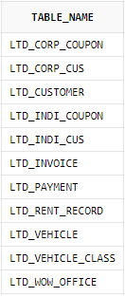

1. **REM: List of Table Columns**

select

table_name, column_name,column_id

from user_tab_columns

where table_name like 'LTD%'

order by table_name,column_id;

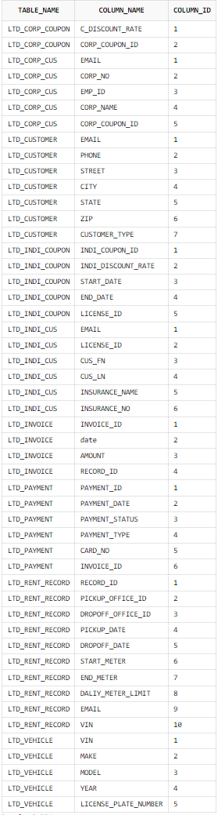

1. **REM: List of Table Column Constraints**

Select table_name,constraint_name,constraint_type,search_condition,index_name,r_constraint_name,delete_rule

from user_constraints

where table_name like LTD%' order by table_name;

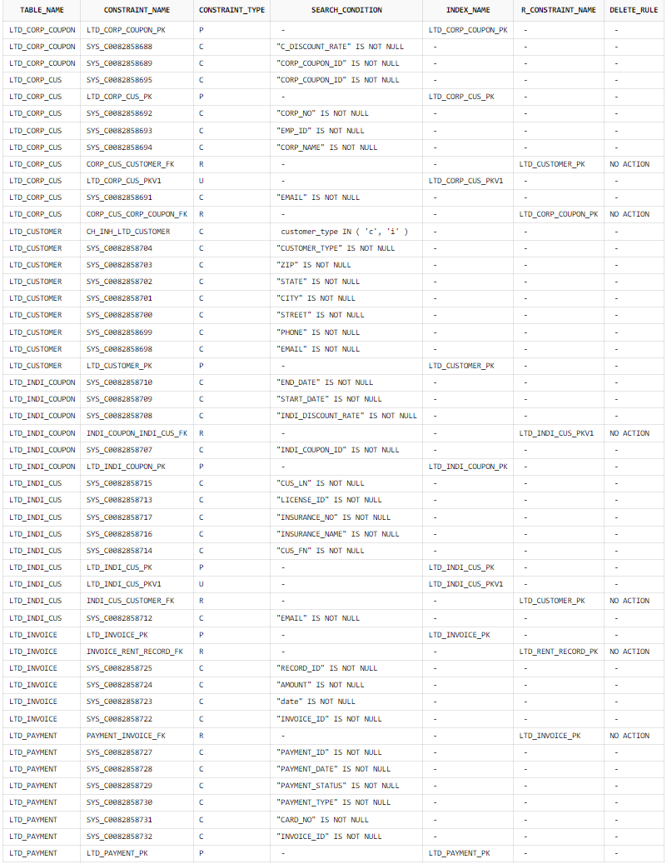

1. **REM: List of Table Column Comments**

select

table_name,column_name,comments

from user_col_comments

where table_name like ‘LTD%'

order by tabl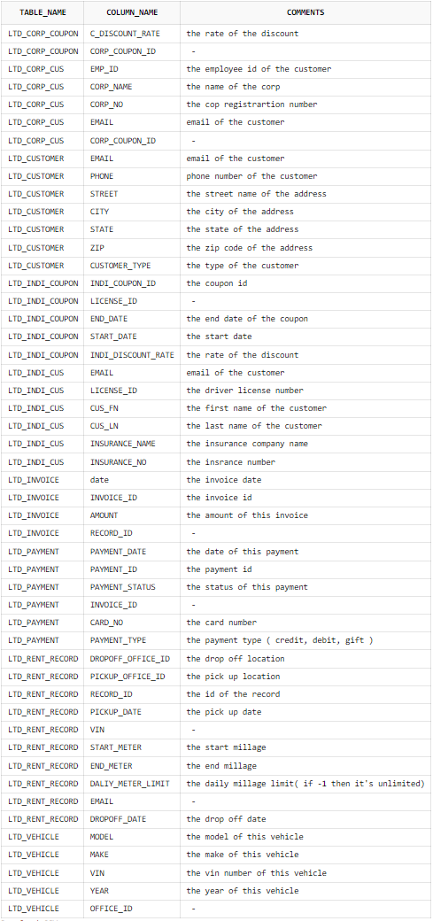e_name;